**APPENDIX F**

**SAMPLE SCREEN SHOTS**

**Mobile – Visitor’s View**

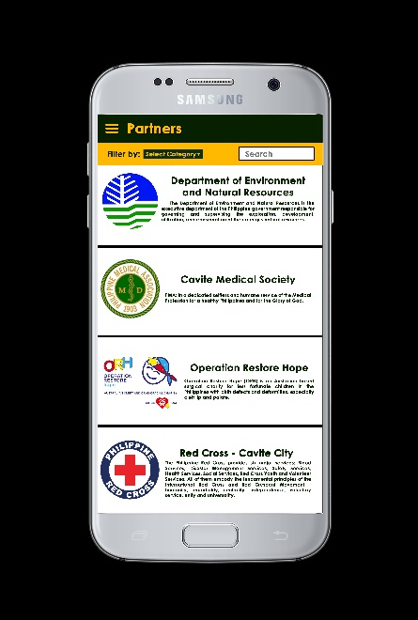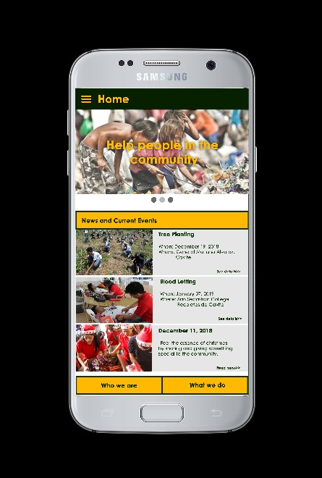

**Figure 1.1**

Home

**Figure 1.2**

Partners

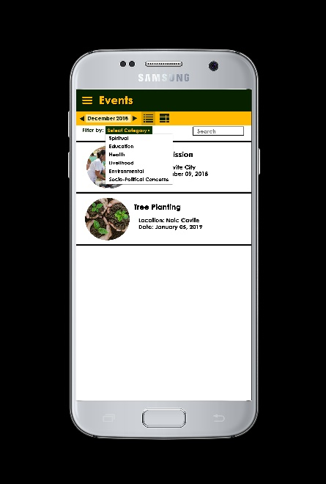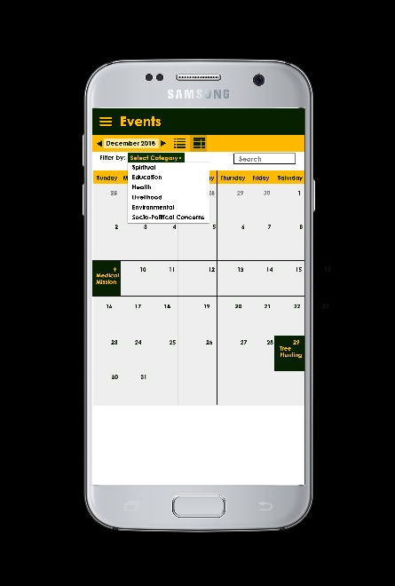

**Figure 1.3**

Events – Calendar View

**Figure 1.4**

Events – List View

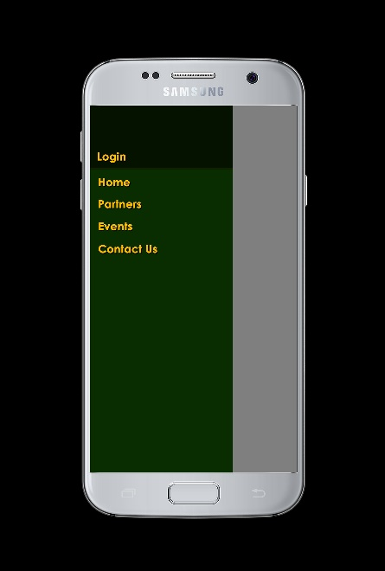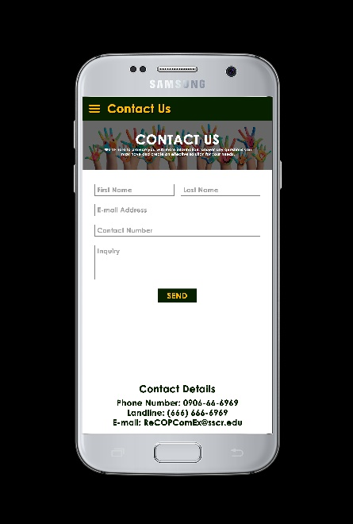

**Figure 1.5**

Contact Us

**Figure 1.6**

Hamburger Menu

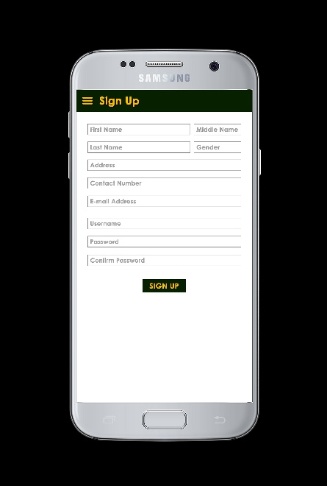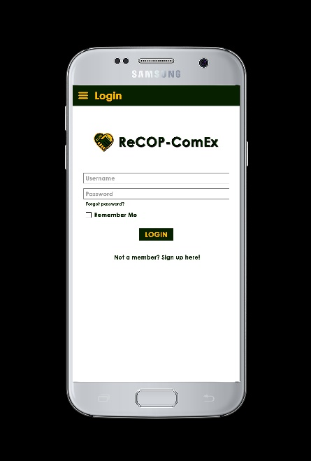

**Figure 1.7**

Login

**Figure 1.8**

Sign Up

**Mobile – Registered User’s View**

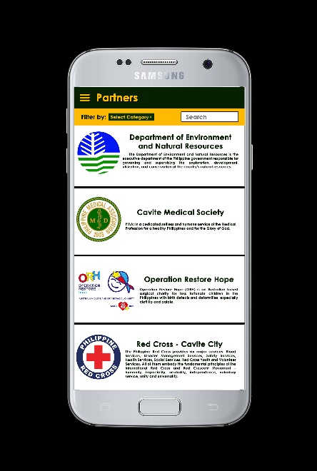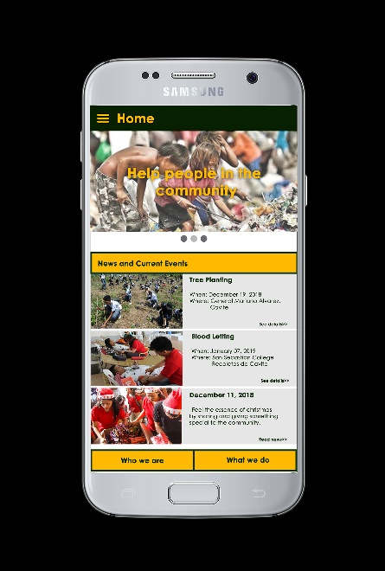

**Figure 2.1**

Home

**Figure 2.2**

Partners

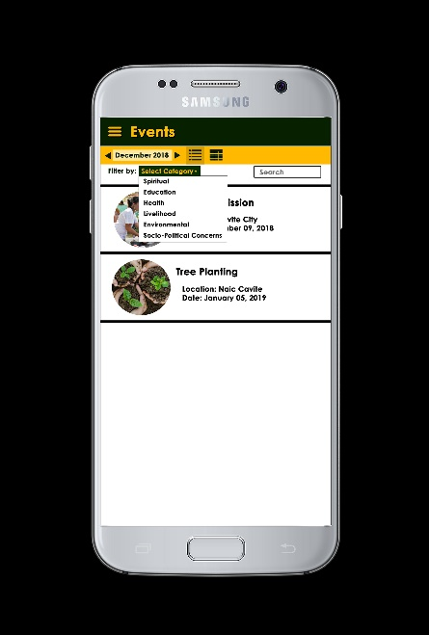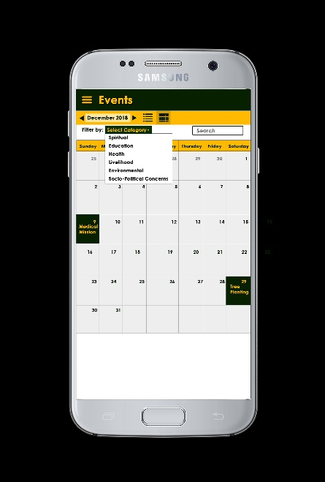

**Figure 2.3**

Events – Calendar View

**Figure 2.4**

Events – List View

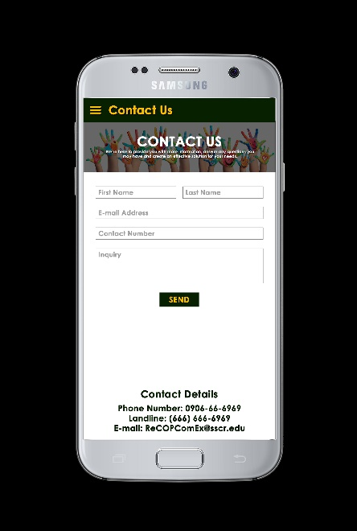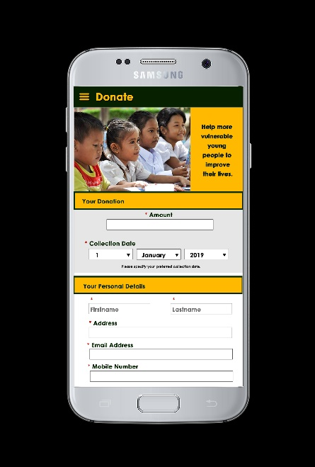

**Figure 2.5**

Donate

**Figure 2.6**

Contact Us

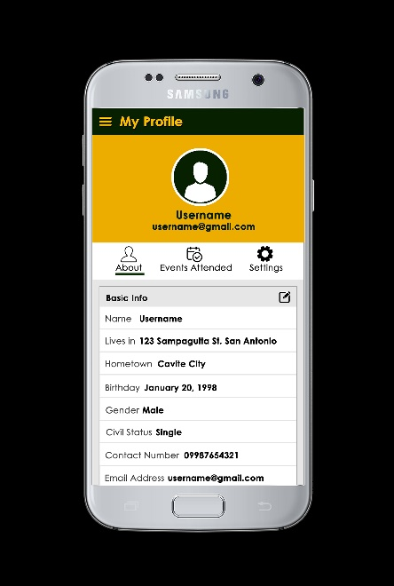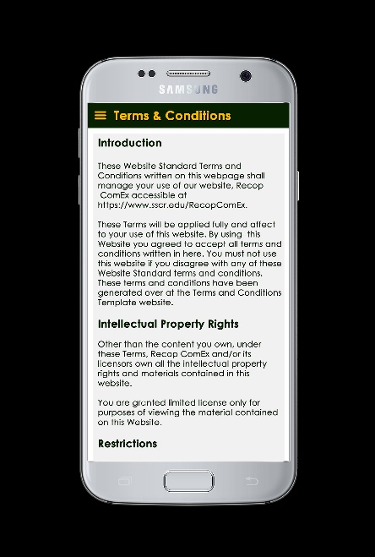

**Figure 2.7**

Terms & Conditions

**Figure 2.8**

My Profile – About

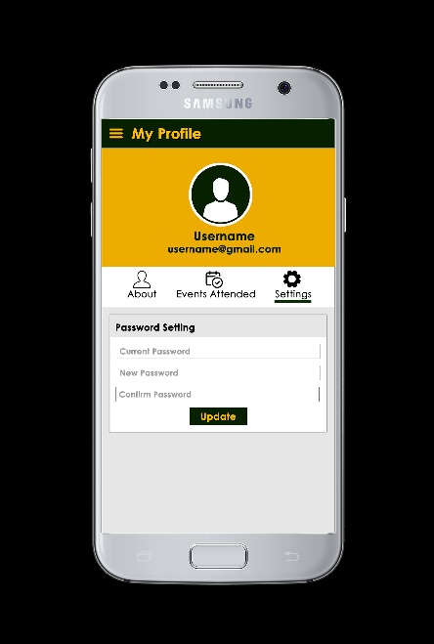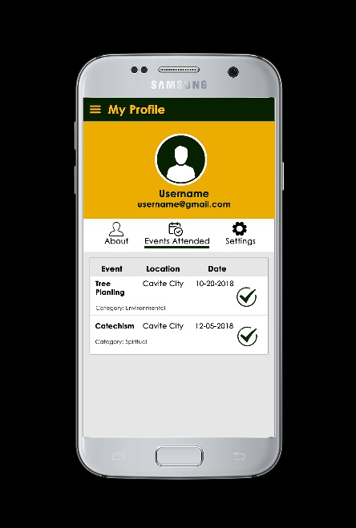

**Figure 2.9**

My Profile – Events Attended

**Figure 2.10**

My Profile – Settings

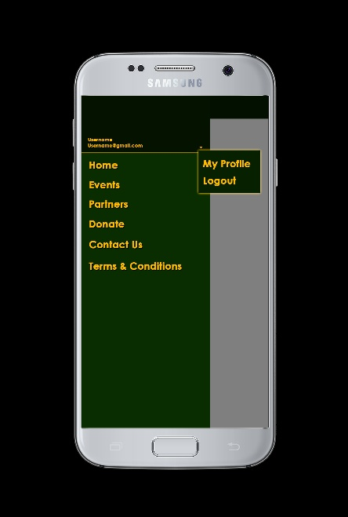

**Figure 2.11**

Hamburger Menu

**Mobile – Partner’s View**

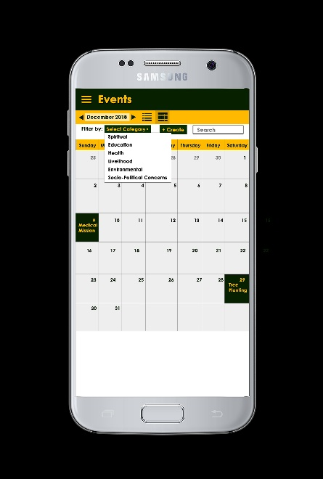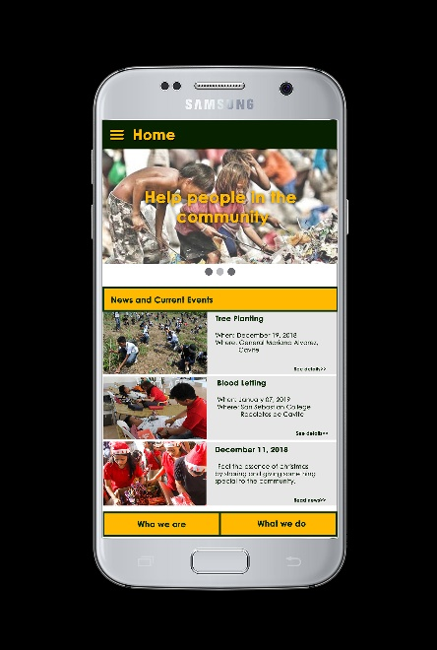

**Figure 3.1**

Home

**Figure 3.2**

Events – Calendar View

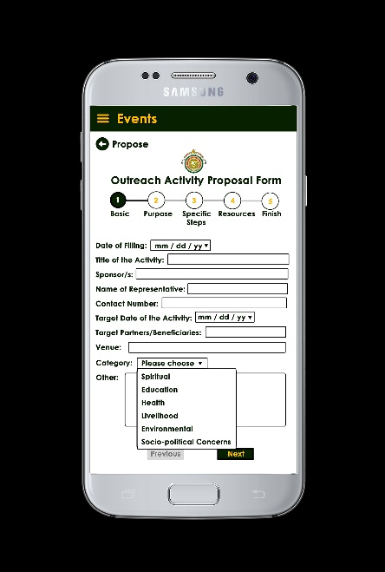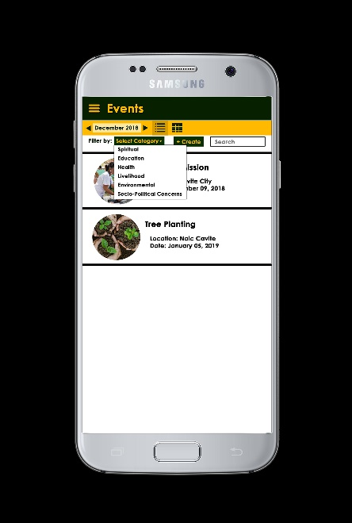

**Figure 3.3**

Events – List View

**Figure 3.4**

Events – Propose

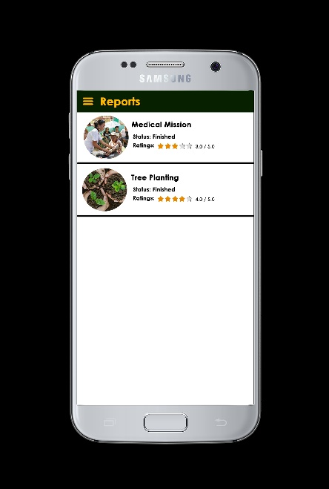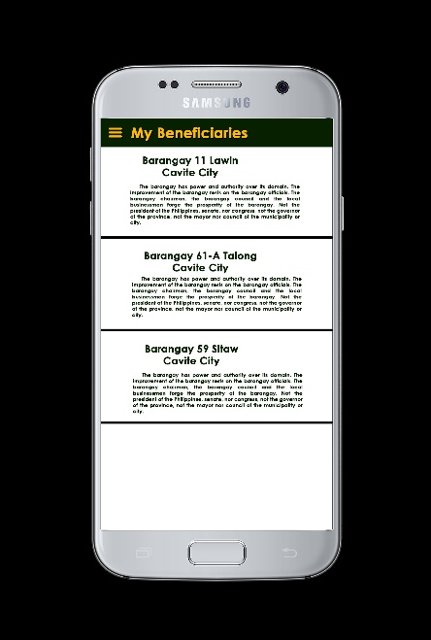

**Figure 3.5**

My Beneficiaries

**Figure 3.6**

Reports

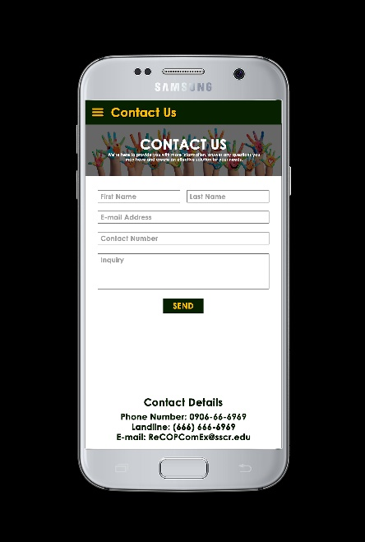

**Figure 3.7**

Contact Us

**Figure 3.8**

Terms & Conditions

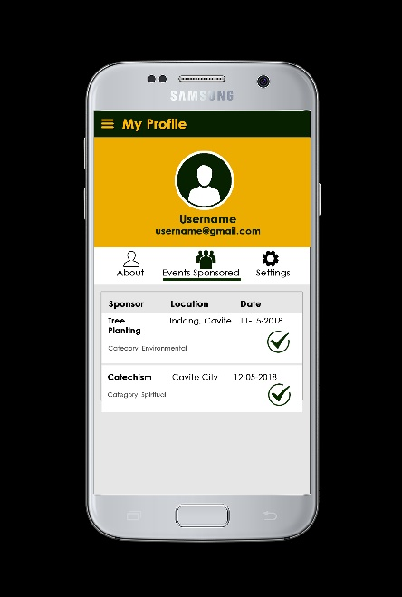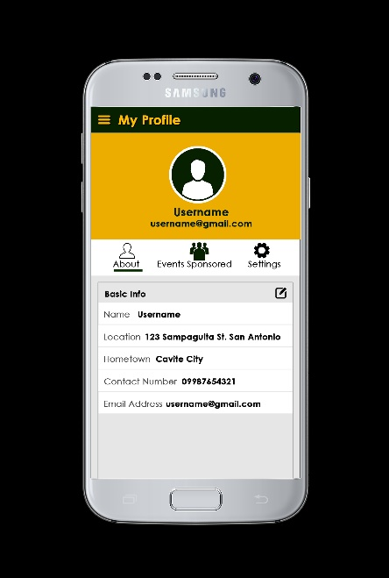

**Figure 3.9**

My Profile – About

**Figure 3.10**

My Profile – Events Attended

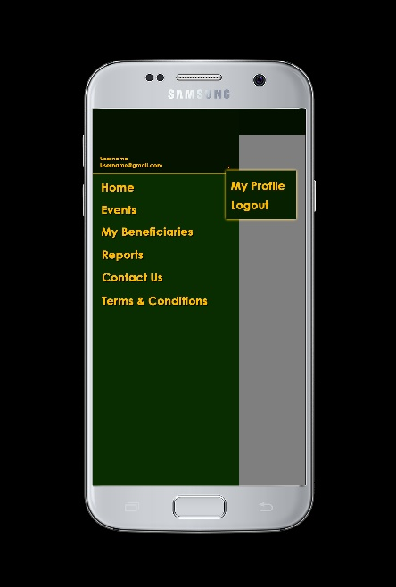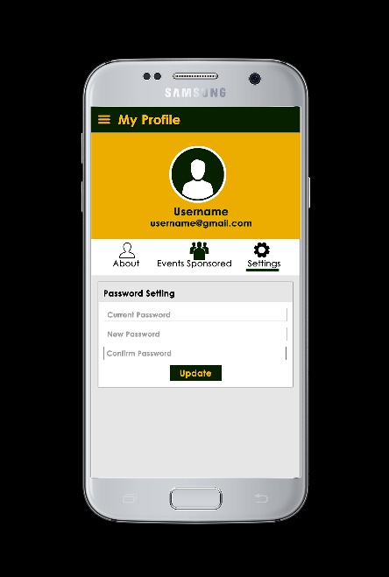

**Figure 3.11**

My Profile – Settings

**Figure 3.12**

Hamburger Menu

**Mobile – Beneficiaries’ View**

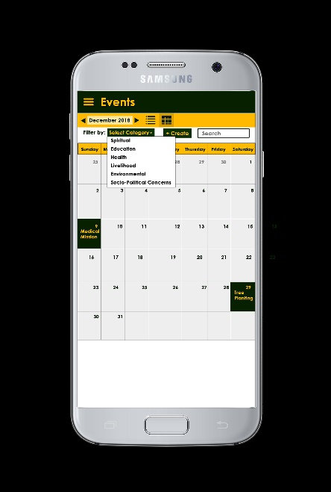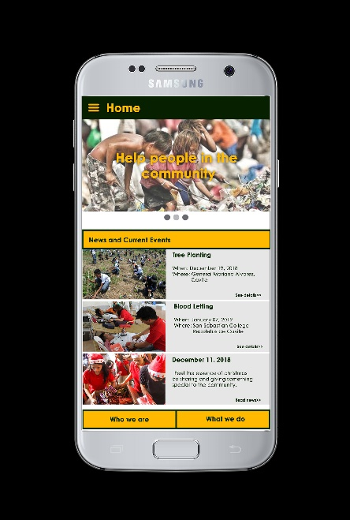

**Figure 4.1**

Home

**Figure 4.2**

Events – Calendar View



**Figure 4.3**

Events – List View

**Figure 4.4**

Reports

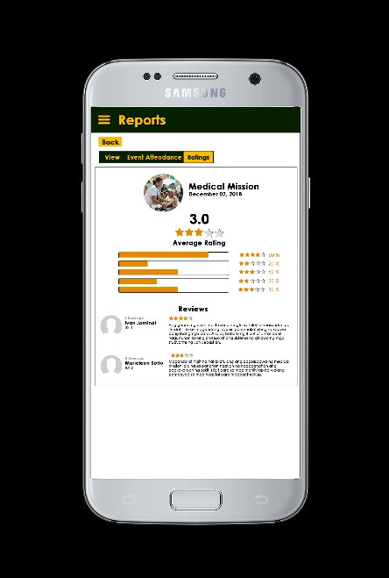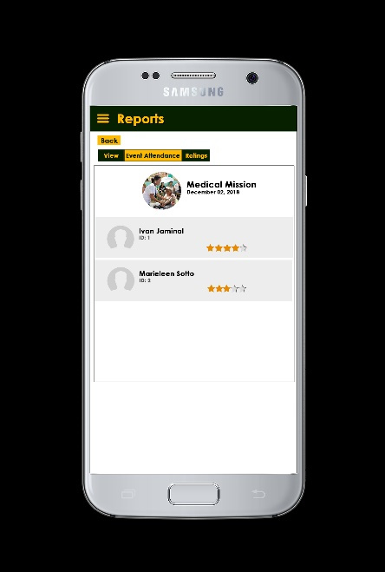

**Figure 4.5**

Reports – Event Attendance

**Figure 4.6**

Reports – Ratings

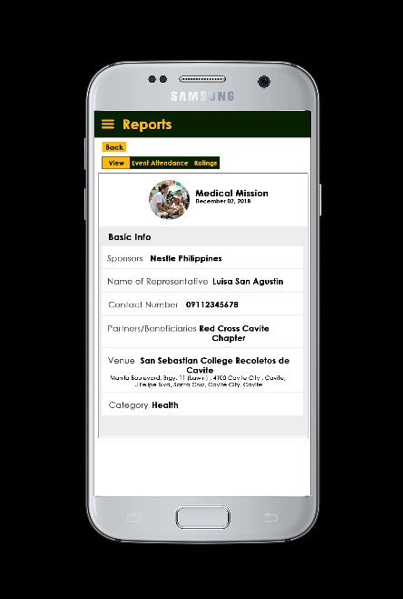

**Figure 4.7**

Reports – View

**Figure 4.8**

Contact Us

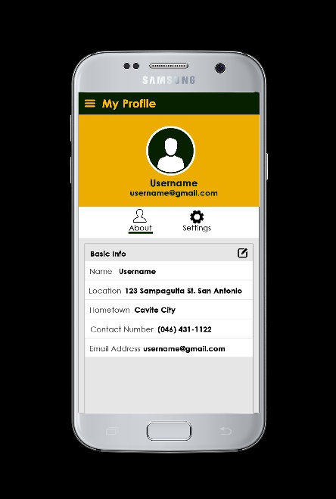

**Figure 4.9**

Terms & Conditions

**Figure 4.10**

Profile – About

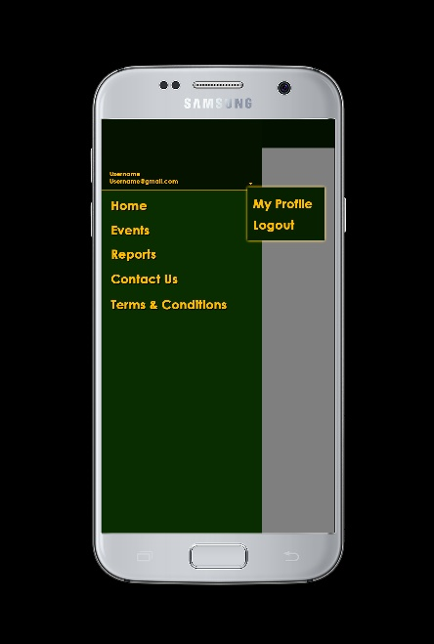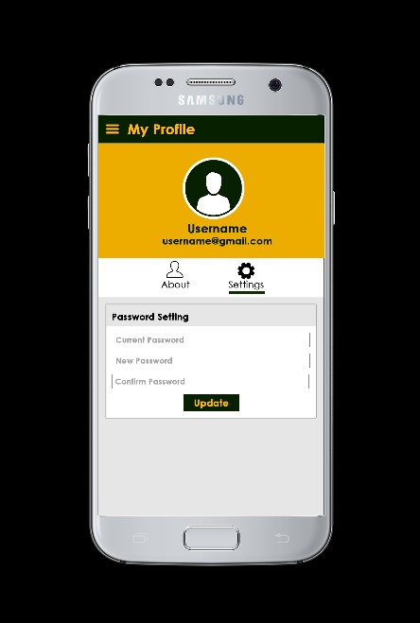

**Figure 4.11**

Profile – Settings

**Figure 4.12**

Hamburger

**Mobile – Administrator’s View**

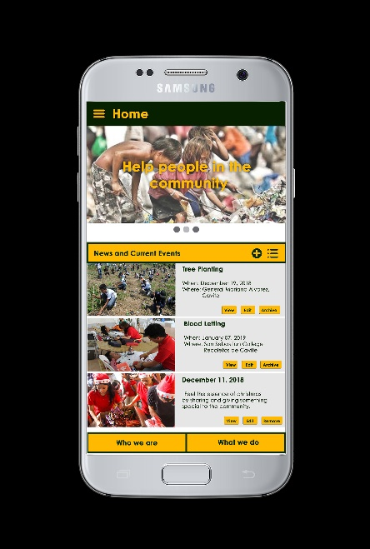

**Figure 5.1**

Home

**Figure 5.2**

Events – Calendar View

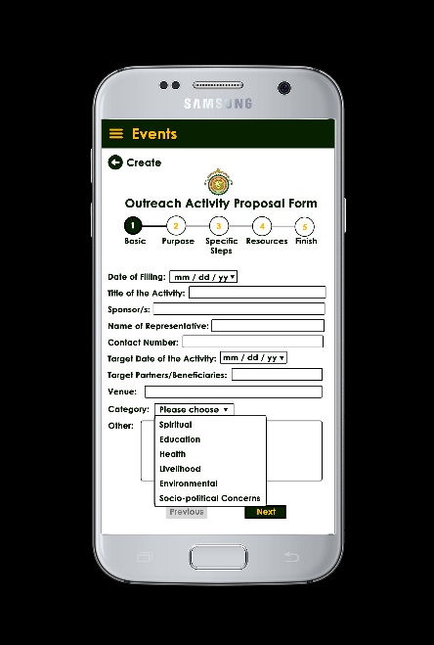

**Figure 5.3**

Events – List View

**Figure 5.4**

Events – Create

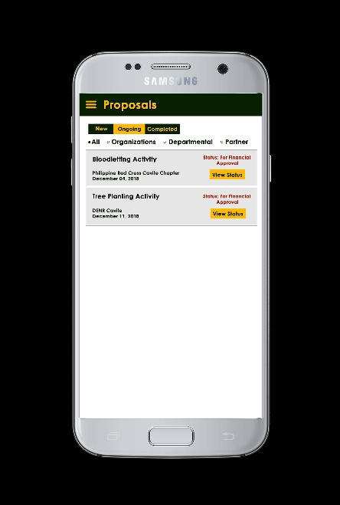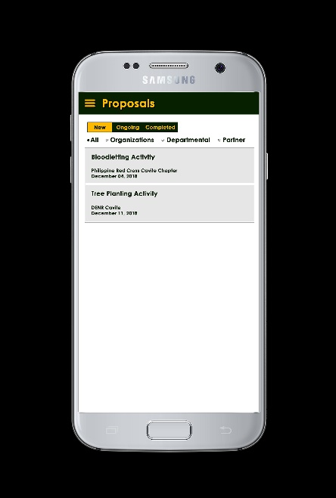

**Figure 5.5**

Proposals – New

**Figure 5.6**

Proposals – Ongoing

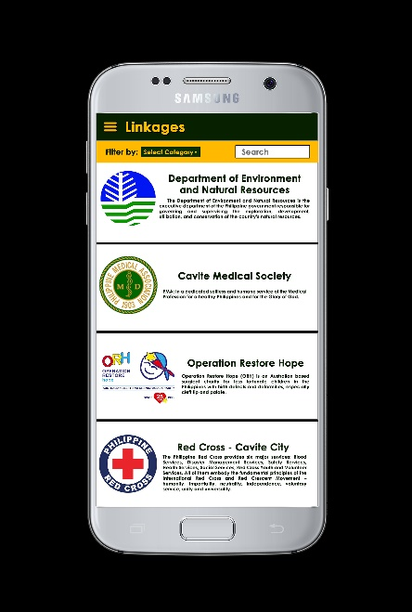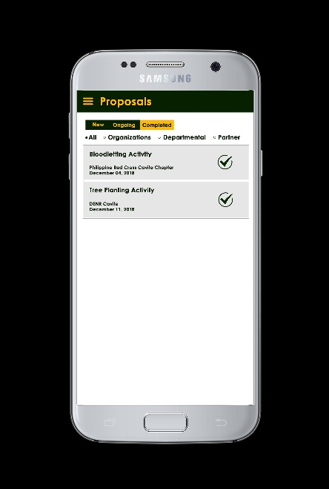

**Figure 5.7**

Proposals – Completed

**Figure 5.8**

Linkages

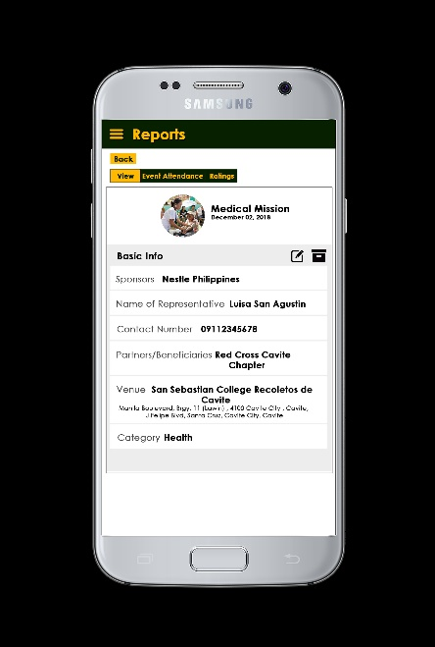

**Figure 5.9**

Reports

**Figure 5.10**

Reports – View



**Figure 5.11**

Reports – Event Attendance

**Figure 5.12**

Reports – Ratings

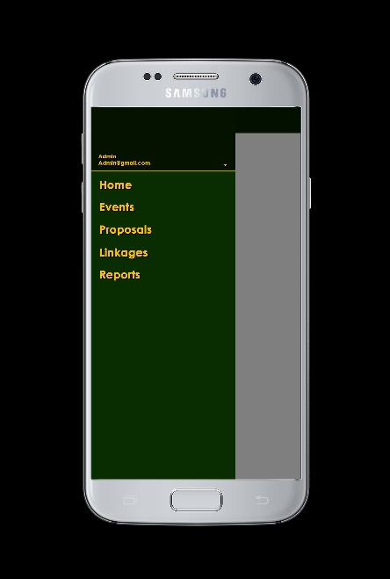

**Figure 5.13**

Hamburger Menu

**Web – Visitor’s View**

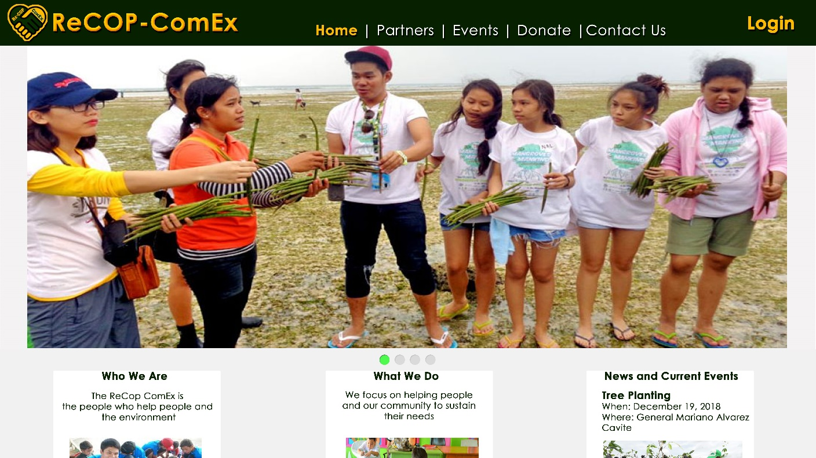

**Figure 1.1**

Home

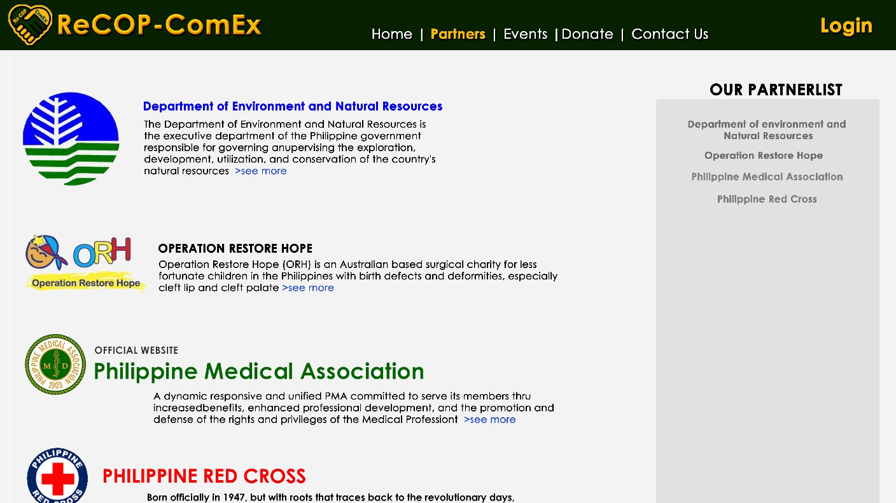

**Figure 1.1**

Partners

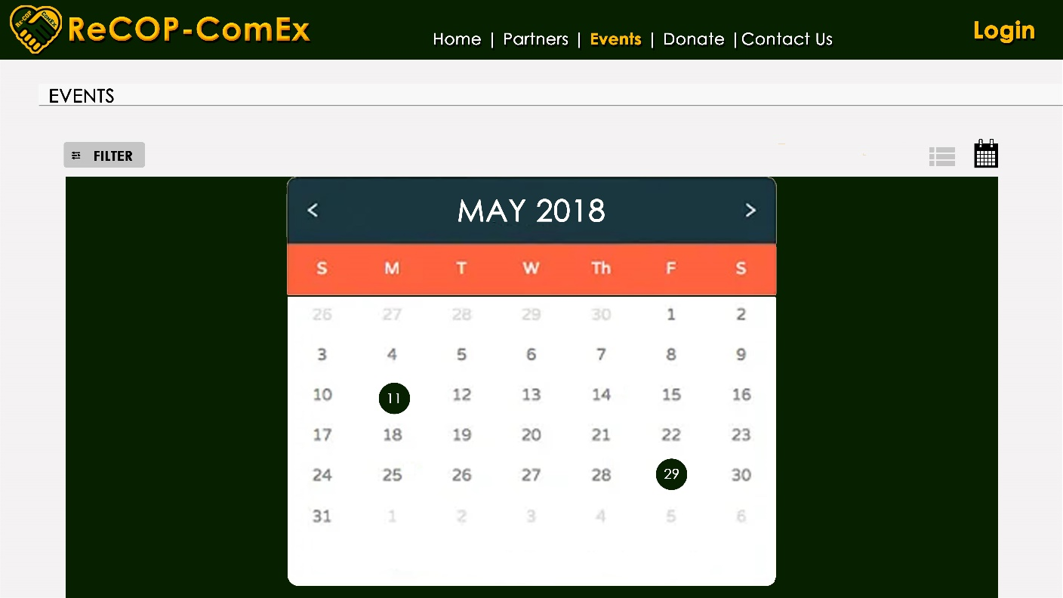

**Figure 1.1**

Events – Calendar View

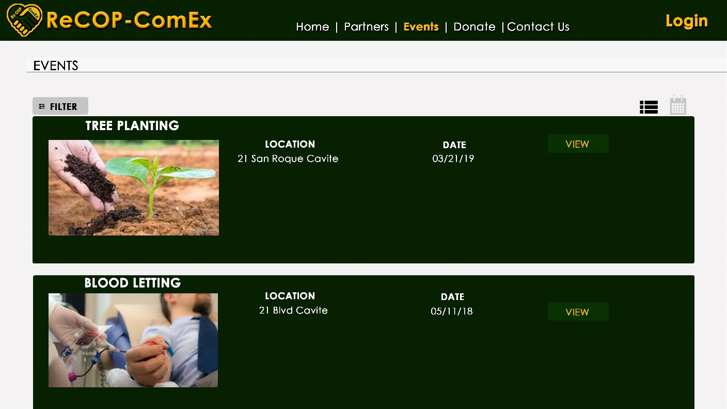

**Figure 1.1**

Events – List View

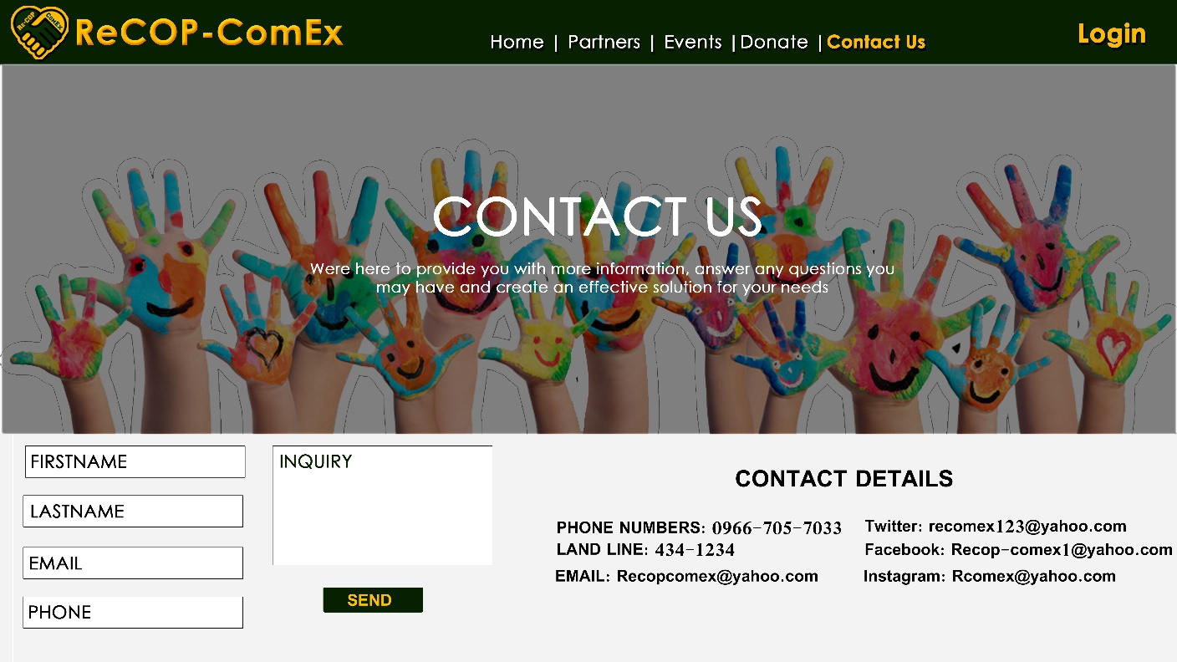

**Figure 1.1**

Contact Us

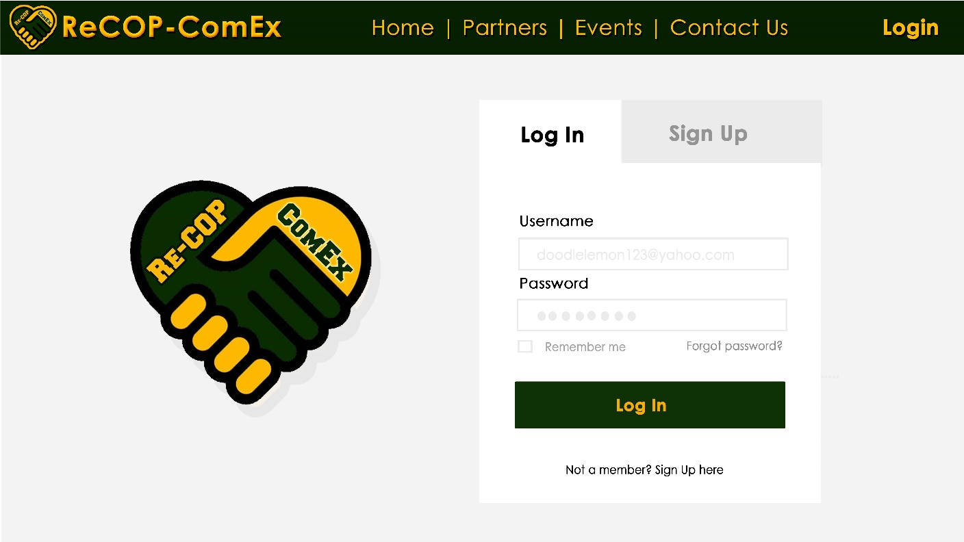

**Figure 1.1**

Login

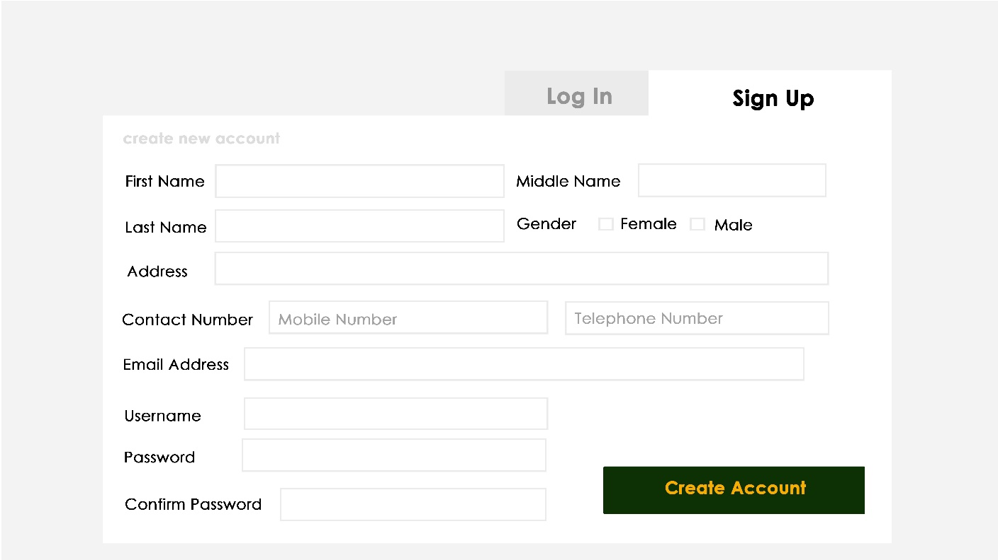

**Figure 1.1**

Sign Up

**Web – Registered User’s View**

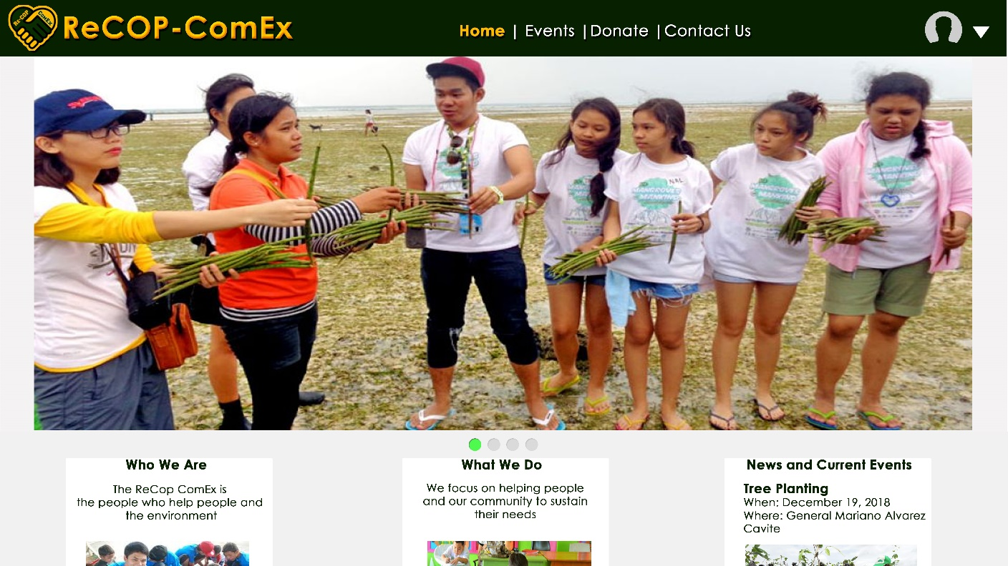

**Figure 1.1**

Home

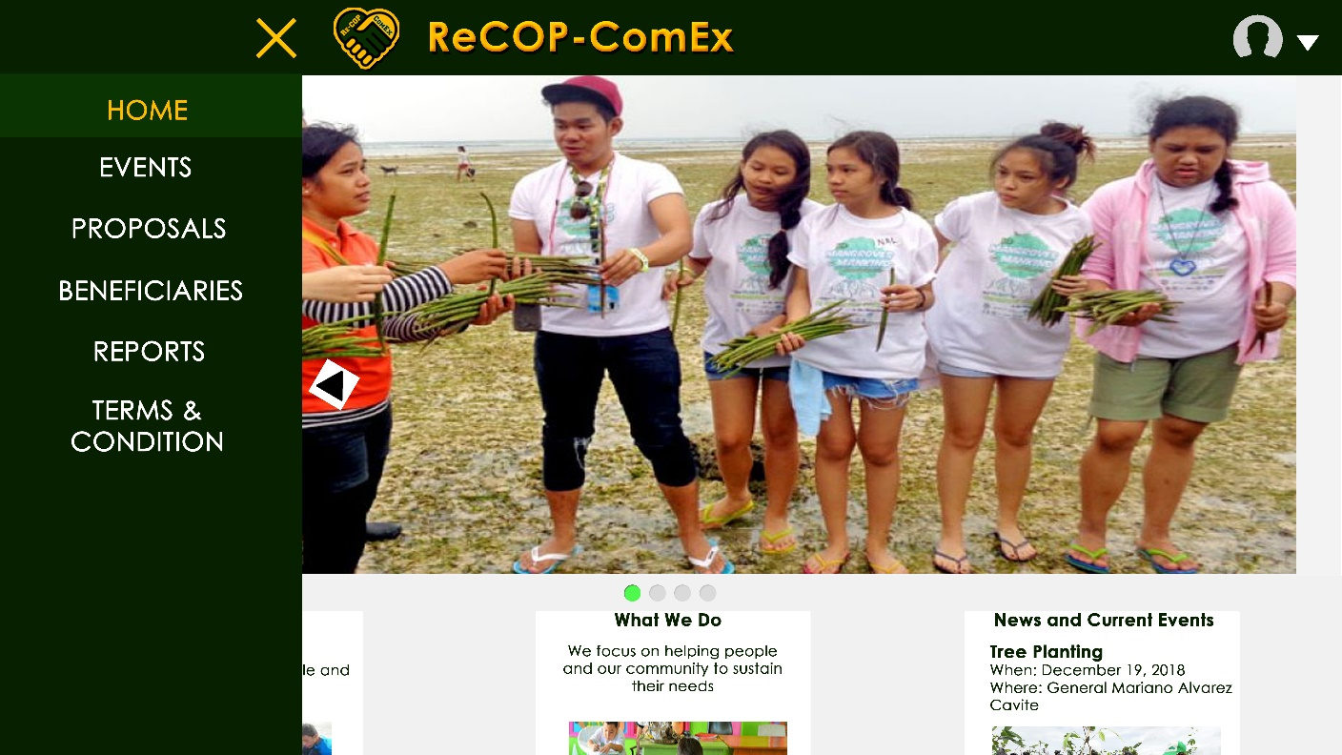

**Figure 1.1**

Partners



**Figure 1.1**

Events – Calendar View



**Figure 1.1**

Events – List View



**Figure 1.1**

Contact Us



**Figure 1.1**

Login